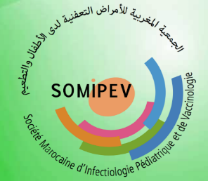

5-7 December 2025 – Marrakech

Resume
your photo here
Last name and first name

TITLE (IN CAPITAL LETTERS, CONCISE AND EXPLICIT)

LAST NAME first name^{1,2*}, LAST NAME first name ¹, LAST NAME first name², LAST NAME first name^{1,2}

Affiliation^{,1} : Laboratoire…, Faculté de Médecine, Université…… – ….., Country
Affiliation^{,2} : Service de pédiatrie, CHU de ….., Country (Medical Sttaf)

First author email
* name@exempel.com

THEMATIC AREAS:
☐ Pediatric Infectiology
☐ Vaccinology
☐ Epidemiology
☐ Prevention

Abstract :
(2300 characters maximum, spaces included – Arial font, size 10)

The resume should be structured as follows:

- Introduction: context and objective(s) of the study
- Methodology: type of study, population, methods used
- Results: main results, key data
- Conclusion: interpretation of the results, perspective

